July 10, 2024


A Raw and Magical Journey into the Life of Iconic Artist Frida Kahlo
“Frida”, directed by Carla Gutiérrez. Available on Amazon. “Frida” is an exquisite documentary; visually stunning, with amazing graphics. It is brought to life with lyrical animation inspired by her unforgettable images; a raw and magical journey into the iconic life of Frida Kahlo, told through her own words.
MUUvies for Change will discuss “Frida” on Wednesday, July 10, at 7pm.
Zoom https://us02web.zoom.us/j/84418593114?pwd=eHI0OExyVWRTSUprTzRqWERvRUp3Zz09
Meeting ID: 844 1859 3114; Passcode: 537288
One tap mobile
+13052241968,,84418593114# US
Find your local number: https://us02web.zoom.us/u/kvLOD4l8Y
Steve Jens-Rochow MUUvies@riverofgrassuu.org

August 14, 2024

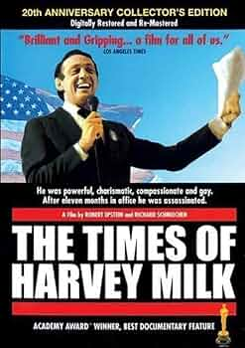

A true twentieth-century trailblazer, Harvey Milk was an outspoken gay activist
“The Times of Harvey Milk” is a documentary of the successful career and assassination of San Francisco's first elected gay city supervisor. Oscar-winning; Harvey Milk was the first openly gay elected city commissioner in America. Directed by Rob Epstein. Available on Amazon.
MUUvies for Change will discuss “The Times of Harvey Milk” on Wednesday, August 14, at 7pm.
Zoom https://us02web.zoom.us/j/84418593114?pwd=eHI0OExyVWRTSUprTzRqWERvRUp3Zz09
Meeting ID: 844 1859 3114; Passcode: 537288
One tap mobile
+13052241968,,84418593114# US
Find your local number: https://us02web.zoom.us/u/kvLOD4l8Y
Steve Jens-Rochow MUUvies@riverofgrassuu.org

September

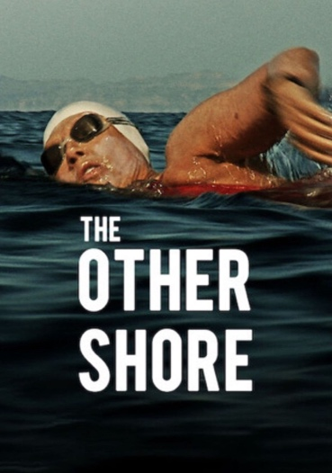

How Drive and Determination Can Make the Impossible Happen for a Grandmother.
Follow legendary 63-year-old swimmer Diana Nyad as she comes out of a 30 year retirement to pursue a perilous goal: swimming from Cuba to Florida without using a protective shark cage. A documentary. Directed by Timothy Wheeler. Available on Amazon and Netflix.
MUUvies for Change will discuss “The Other Shore” on Wednesday, September 11, at 7pm.
Zoom https://us02web.zoom.us/j/84418593114?pwd=eHI0OExyVWRTSUprTzRqWERvRUp3Zz09
Meeting ID: 844 1859 3114; Passcode: 537288
One tap mobile
+13052241968,,84418593114# US
Find your local number: https://us02web.zoom.us/u/kvLOD4l8Y
Steve Jens-Rochow MUUvies@riverofgrassuu.org

October


“Ladies and gentlemen, this is fighting Shirley Chisholm coming through.”
“Shirley” is a biographical drama film written and directed by John Ridley. Shirley Chisholm was the first Black woman to be elected to the United States Congress. She become the first Black candidate to run for a major-party nomination for president in 1972 and the first woman to run for the Democratic Party's nomination. She represented Brooklyn for 7 terms. Available on Netflix.
MUUvies for Change will discuss “Shirley” on Wednesday, October 9, at 7pm.
Zoom https://us02web.zoom.us/j/84418593114?pwd=eHI0OExyVWRTSUprTzRqWERvRUp3Zz09
Meeting ID: 844 1859 3114; Passcode: 537288
One tap mobile
+13052241968,,84418593114# US
Find your local number: https://us02web.zoom.us/u/kvLOD4l8Y
Steve Jens-Rochow MUUvies@riverofgrassuu.org

November


A searingly honest look at a living legend.
“I am a Noise” is a raw and intimate portrait of the legendary folk singer and activist. The film utilizes previously unreleased home movies, artwork, diaries, therapy tapes, and audio recordings related to Joan Baez. It is a depiction of her personal journey from pain to peace and forgiveness. Available on Netflix.
MUUvies for Change will discuss “I am a Noise” on Wednesday, November 13, at 7pm.
Zoom https://us02web.zoom.us/j/84418593114?pwd=eHI0OExyVWRTSUprTzRqWERvRUp3Zz09
Meeting ID: 844 1859 3114; Passcode: 537288
One tap mobile
+13052241968,,84418593114# US
Find your local number: https://us02web.zoom.us/u/kvLOD4l8Y
Steve Jens-Rochow MUUvies@riverofgrassuu.org

December

`

Amusing, uplifting, it puts the emphasis on play and uplift.
The Beautiful Game celebrates the healing power of team sports for those who are pushed to society’s margins by misfortune. As an English soccer squad heads to Rome for the Homeless World Cup, their talented new player must let go of his past and learn to be part of a team. A feel-good story with a happy-ending that revolves mostly around the fortunes of a half dozen unhoused men. Directed by Thea Sharrock. Available on Netflix.
MUUvies for Change will discuss “The Beautiful Game” on Wednesday, December 11, at 7pm.
Zoom https://us02web.zoom.us/j/84418593114?pwd=eHI0OExyVWRTSUprTzRqWERvRUp3Zz09
Meeting ID: 844 1859 3114; Passcode: 537288
One tap mobile
+13052241968,,84418593114# US
Find your local number: https://us02web.zoom.us/u/kvLOD4l8Y
Steve Jens-Rochow MUUvies@riverofgrassuu.org

